|  |  |  |  |  |  |  |  |
| --- | --- | --- | --- | --- | --- | --- | --- |
| **Date:** | **20-06-2020** | | | | **Name:** | **PALLAVI** | |
| **Sem & Sec** | **6th - A** | | | | **USN:** | **4AL17CS056** | |
| **Online Test Summary** | | | | | | | |
| **Subject** | **Programming in C++** | | | | | | |
| **Max. Marks** | **-** | | **Score** | | | **-** | |
| **Certification Course Summary** | | | | | | | |
| **Course** | **1.Pre-Placement Training** | | | | | | |
| **Certificate Provider** | | **-** | | **Duration** | | | **-** |
| **Coding Challenges** | | | | | | | |
| **Problem Statement:1 Java program 1 C program** | | | | | | | |
| **Status: Executed** | | | | | | | |
| **Uploaded the report in GitHub** | | | | **yes** | | | |
| **If yes Repository name** | | | | <https://github.com/pallavi056/DAILY_STATUS> | | | |
| **Uploaded the report in slack** | | | | **Yes** | | | |

**Class and Quiz Snapshots:**

**Programming in C++:**

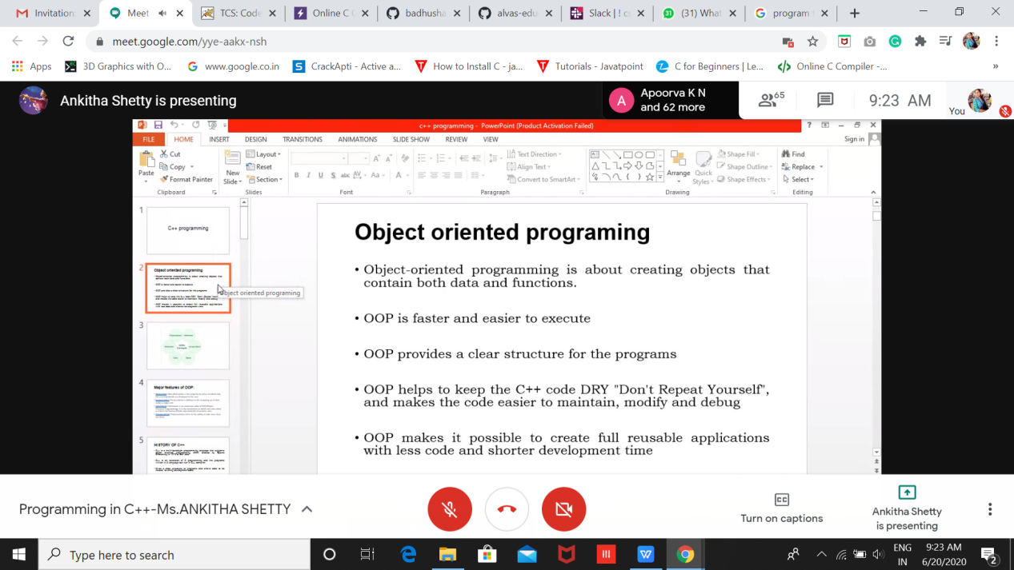

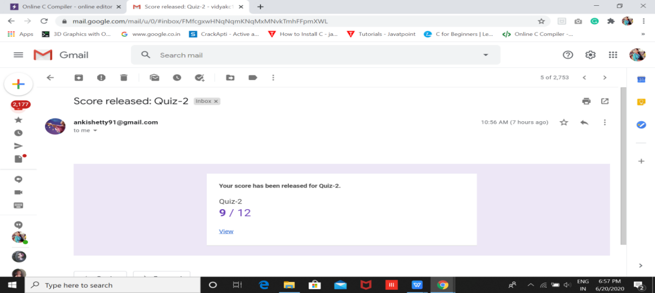

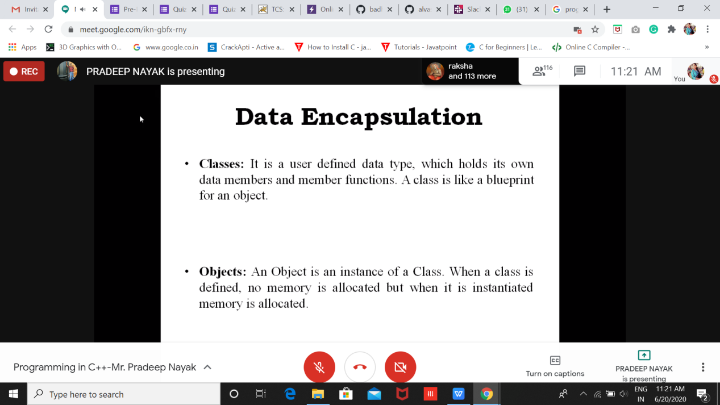

Coding Challenges Details: (Attach the snapshot and briefly write the report for the same

**Coding Challenges Details:**[https://github.com/pallavi056/DAILY_STATUS/tree/master/20-6-2020/ONLINE%20CODING](https://github.com/pallavi056/DAILY_STATUS/tree/master/20-6-2020/ONLINE CODING)

Refer the github link for detail information :Solved all the problems and the solutions are uploaded in github account.